How to use SUMIF in Excel:

Now let’s try and understand how to apply a SUMIF formula.

Suppose we have a sales table as shown below:

[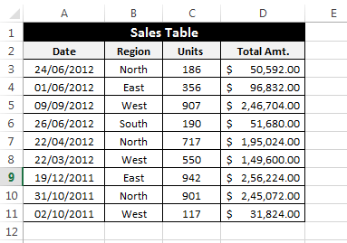](https://i1.wp.com/www.exceltrick.com/wp-content/uploads/2013/04/How-to-use-SUMIF-Image1.png)

Objective: Our objective is to find the Total Sales Amount earned from North region.

Let’s try to apply a SUMIF to find the solution.

[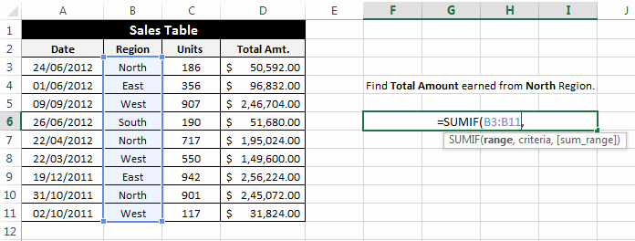](https://i2.wp.com/www.exceltrick.com/wp-content/uploads/2013/04/How-to-use-SUMIF-Image2.png)

range: In the ‘range’ argument select the cells that include your criteria.

[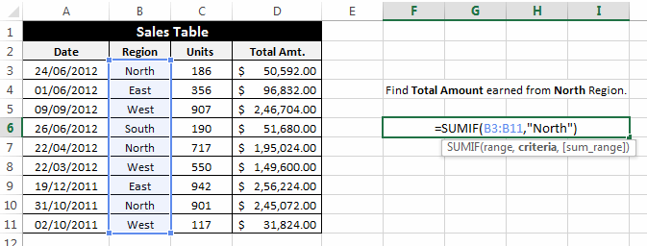](https://i1.wp.com/www.exceltrick.com/wp-content/uploads/2013/04/How-to-use-SUMIF-Image3.png)

criteria: In the ‘criteria’ argument enter your criteria i.e. “North” Region. Please note that writing “=North” is same as writing “North”.

[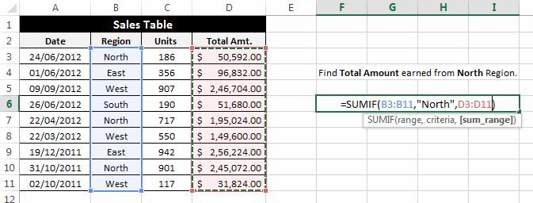](https://i1.wp.com/www.exceltrick.com/wp-content/uploads/2013/04/How-to-use-SUMIF-Image4.png)

sum_range: In the ‘sum_range’ argument select the cells that should be added after evaluating the criteria.

[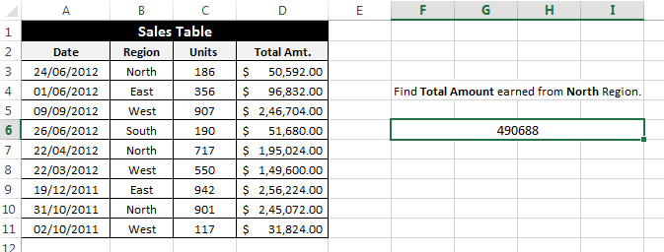](https://i2.wp.com/www.exceltrick.com/wp-content/uploads/2013/04/How-to-use-SUMIF-Image5.png)

After applying this formula the result comes out as: 490688 which is the addition of D3, D7 and D10.

https://www.exceltrick.com/formulas_macros/excel-sumif-and-sumifs/